Robert Kroeger’s
“Barns of Highland County” Art Auction
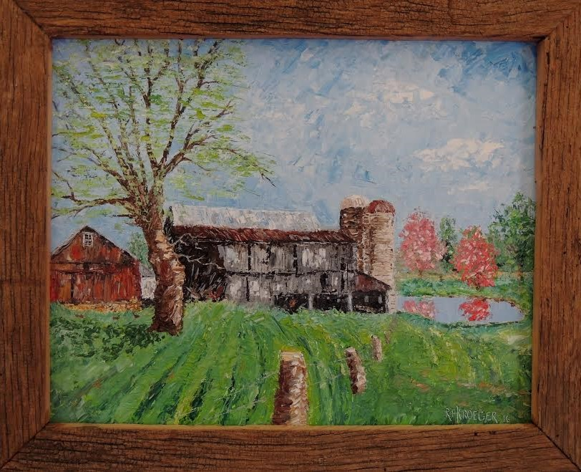
to benefit the Highland County Historical Society
The auction will be held at the Highland House Museum
151 East Main Street in Hillsboro, Ohio at the annual
Log Cabin Cookout
Saturday, September 24th
Serving of the bean dinner will begin at 5:00
With the auction starting at 6:00
Call the museum at 937 393-3392 for reservations
There is no charge…but donations are gladly accepted!

